# **Backup Database**

* Expand the "Databases" tree
* Right click on the database name you want to backup
* Select "Tasks" then "Back Up..." as shown below

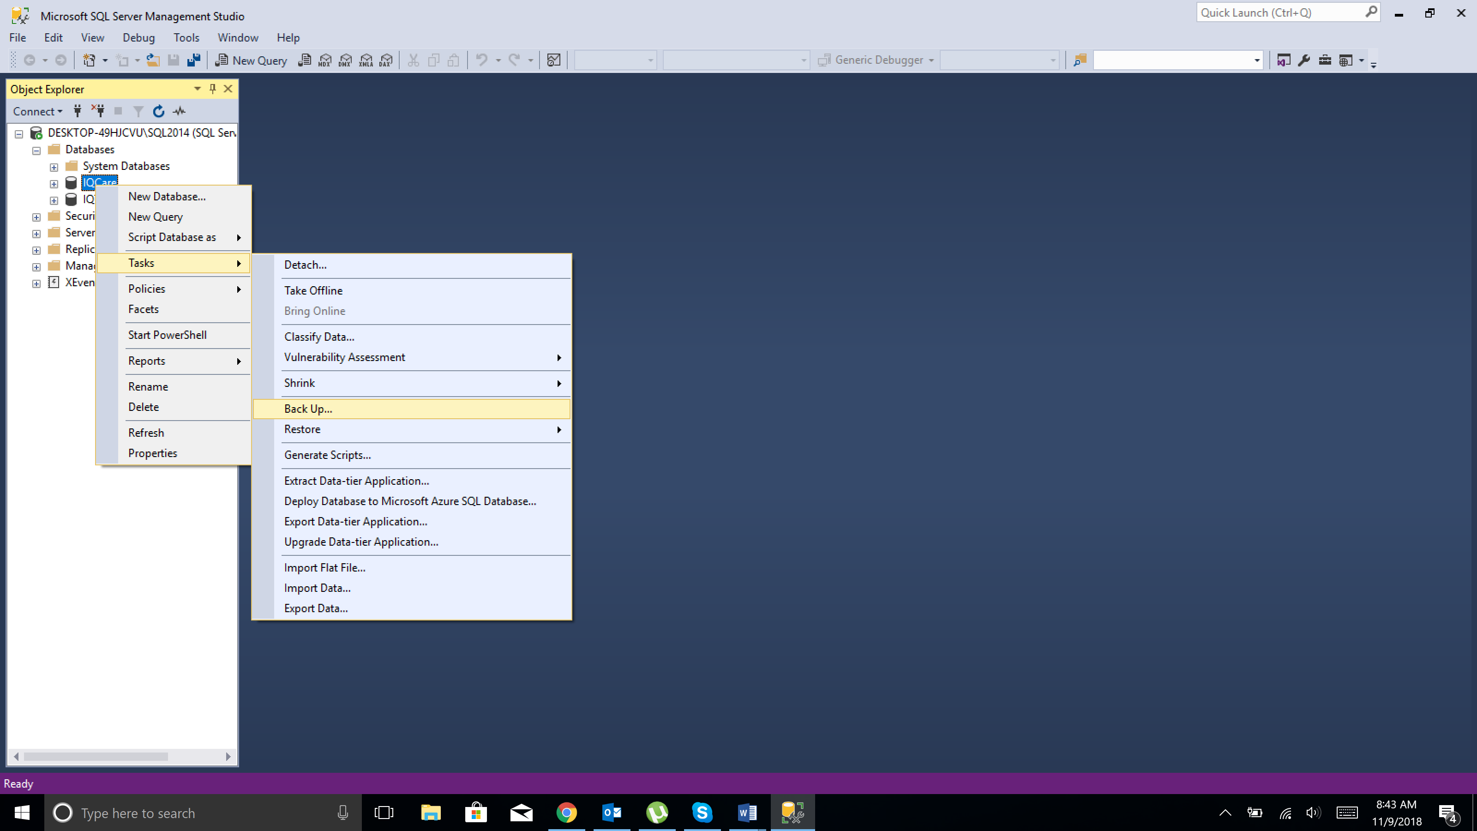

* Click on "Add..." to add the location and the name of the backup file

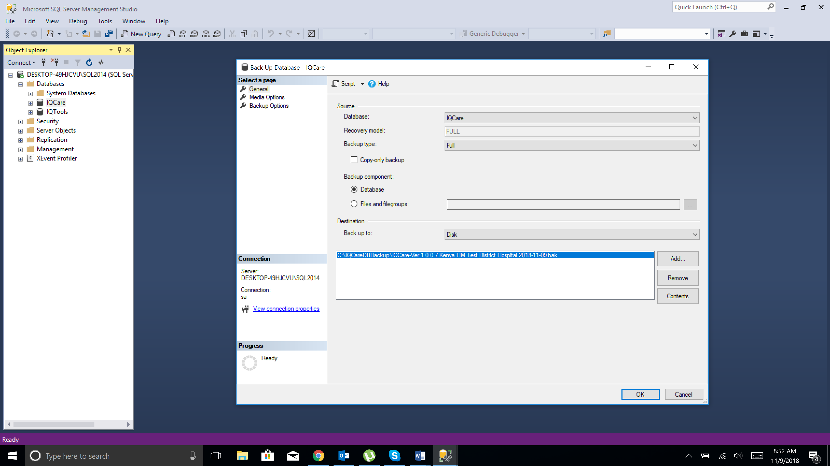

* Specify backup location

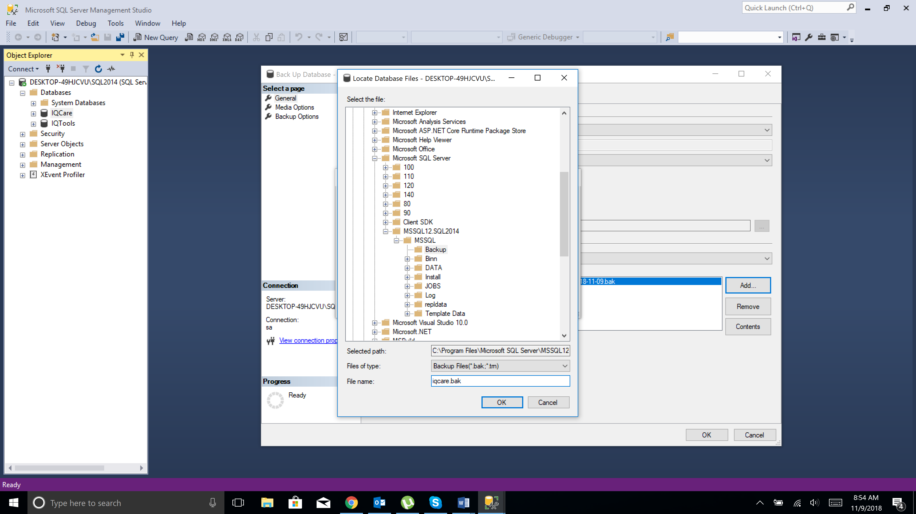

* Click "OK" to close this screen

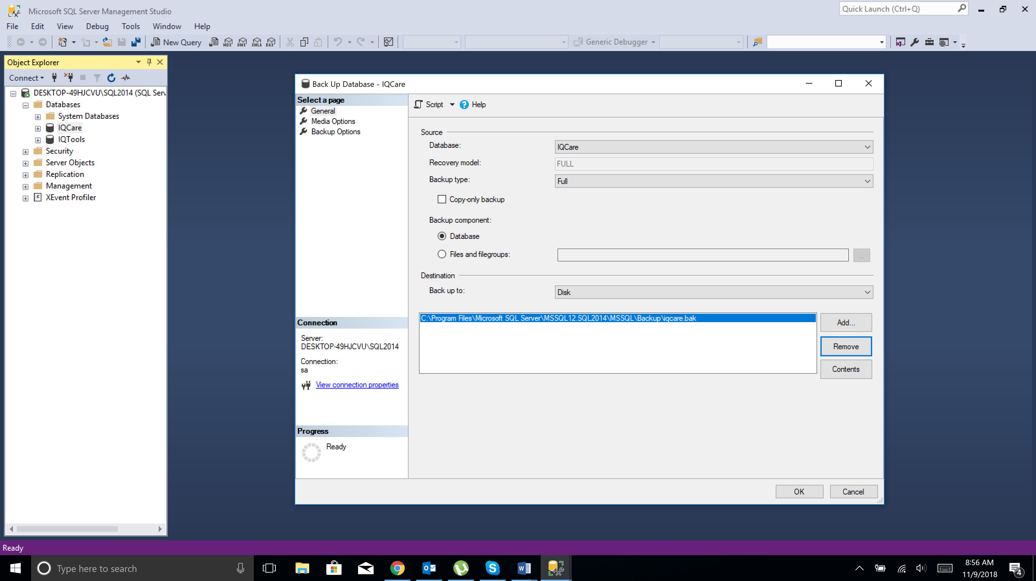

* And click "OK" again to create the backup